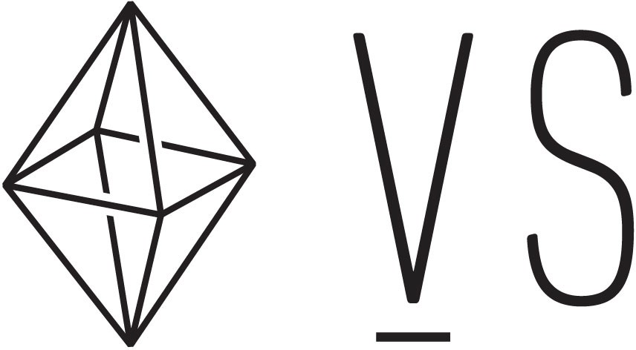

 MENU

[(https://coursework.vschool.io)](https://coursework.vschool.io/)

Caeser Cipher

[18 MAY 2015 on Exercise (/tag/exercise/), Programming Principles (/tag/programming- principles/),](https://coursework.vschool.io/tag/programming-principles/) [Level 2 (/tag/level-2/)](https://coursework.vschool.io/tag/level-2/)

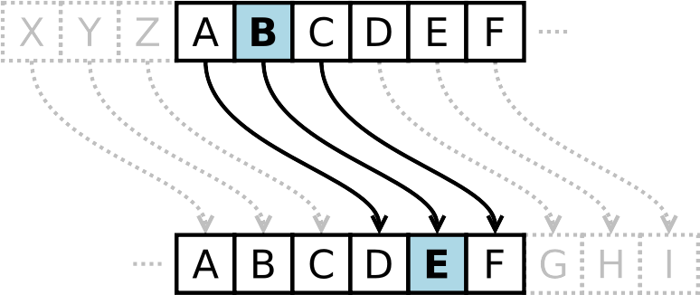

*In cryptography, a Caesar cipher, also known as Caesar's cipher, the shift cipher, Caesar's code or Caesar shift, is one of the simplest and most widely known encryption techniques. It is a type of substitution cipher in which each letter in the plaintext is replaced by a letter some ixed number of positions down the alphabet." -*[*Wikipedia (http://en.wikipedia.org/wiki/Caesar_cipher)*](http://en.wikipedia.org/wiki/Caesar_cipher)

For this exercise, you will be implementing a Caeser cipher using Javascript. Your program will receive two inputs:

1. The text to be encoded
2. The number positions to shift each letter (to the right) For example:

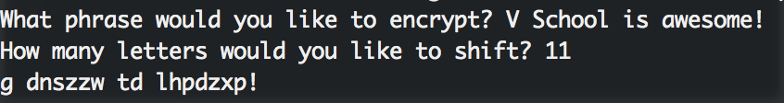

You only have to shift letters that are part of the 26-letter alphabet. Any other characters (such as spaces) should be printed as they were received. The shift value will always be on the interval [0, 26].

Here is some code to get you started:

From terminal:

# cd into your caesar-cipher folder first, then run: npm install readline-sync

In your code:

var readline = require('readline-sync');

var input = readline.question('What phrase would you like to encrypt? '). var shift = parseInt(readline.question('How many letters would you like t

[Robert Williams (/author/robert/)](https://coursework.vschool.io/author/robert/)

Read [more posts (/author/robert/)](https://coursework.vschool.io/author/robert/) by this author.

Share this post

* (https://twitter.com/i text=Caeser%20Cipher&

SEARCH!

Search for another post

[(/git- rundown/)](https://coursework.vschool.io/git-rundown/)

[READ THIS NEXT](https://coursework.vschool.io/git-rundown/)

[YOU MIGHT ENJOY](https://coursework.vschool.io/battleship/)

[(/battleship/)](https://coursework.vschool.io/battleship/)

# [Git Rundown](https://coursework.vschool.io/git-rundown/)

[The Importance of Version Control What is git? Git is a distributed version control system. Distributed: Files are stored…](https://coursework.vschool.io/git-rundown/)

# [Battleship](https://coursework.vschool.io/battleship/)

[You are going to create a simplified version of the game Battleship. You will create a grid system and…](https://coursework.vschool.io/battleship/)

[**V School | Human-centered Ed Tech (https://coursework.vschool.io)**](https://coursework.vschool.io/) [© 2019](https://coursework.vschool.io/git-rundown/)

[Proudly published with](https://coursework.vschool.io/battleship/) [**Ghost (https://ghost.org)**](https://ghost.org/)